Contact Lens 1 BOPT 4702

Lecture 1
Topic: Anatomy and Physiology of Anterior segment of the eye
Aim: the aim of the course is to review ocular anatomy and physiology as related to contact lens practice.

Objectives:
At the end of this lecture the student should be able to:
Explain the normal structural components of the anterior segment and how they relate to contact lenses
Describe the physiology of the tissue components of the anterior segment and its relevance to contact lenses
Understand how changes in the normal parameters of the anterior segment can be produced
Explain how the various significant parameters of teh anterior segment relevant for contact lenses can be measured
Time: 2 hours
Materials Required: Lecture video, textbooks, iacle PDF, journal articles,
Method: class discussion with presentations by students
Assessment: pop quiz

Test your Knowledge
The most important part of the anterior eye for contact lens wear is the sclera (T/F)
To appreciate contact lens wear, its complication and requirements you must understand the anatomy of the cornea, conjunctiva, lacrimal system, eyelids, tear film and its drainage (T/F)
The cornea enjoys wettability like the rest of the various tissues of the body (T/F)
Corneal swelling is directly related to the efficiency of the endothelial pump (T/F)
To assess Tear Film you must use a Slit lamp (T/F)

Scenario 1
As the head of a student support group for students in level 2 for Ocular anatomy and Physiology; the students would like to know how related their course is to contact lenses. Using specific examples from parts of the anterior segment, explain clearly why a good knowledge of anatomy and physiology is a prerequisite for contact lenses. How relevant is it to contact lens practice?

Lecture 2
Topic: History of Contact Lenses
Aim: the aim of the course is to expose the students to relevant history of contact lenses to build appreciation of the various trends with respect to its practice.

Objectives:
At the end of this lecture the student should be able to:
Identify significant contributors to the development of contact lenses
Identify related dates of interest in contact lens development
Know the key manufacturers that have been involved in the development of contact lens practice
Time: 1 hour
Materials Required: Lecture video, textbooks, iacle PDF, journal articles,
Method: class discussion with presentations by students
Assessment: none

Test your Knowledge
Contact lenses started on the theories postulated by some well-known persons, some of whose theories could not be proven at their time. (T/F)
The history of contact lenses sis in the following logical order, micro corneal, corneal, PMMA (T/F)
Gp contact lens material can be traced back to 1968 (T/F)
One popular name associated with soft contact lens (scl) is wichterle in 1952 (T/F)
The most current development of contact lenses can be attributed to Google contact
lenses (T/F)

Scenario 2
You have been invited to level one introp class to talk about contact lenses. The organizer has tasked you with tracing the recent history of contact lenses. Who would you identify as the early theorist, developers, and why? What conditions or factors facilitated the development of contact lenses? How has contact lenses, its materials and manufacture changed overtime? What would you regard as the current history of contact lenses?

Lecture Outline
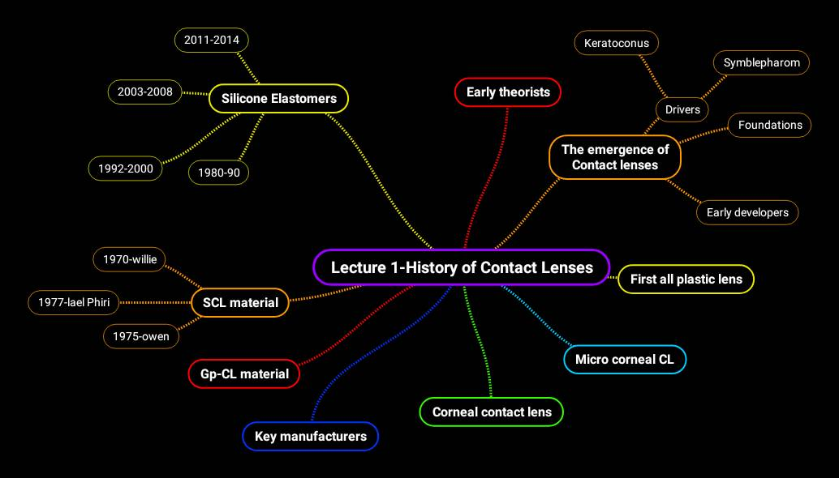

Lecture 3
Topic: Contact Lens Optics
Aim: the aim of the course is to compare optical principles between spectacles and contact lenses.

Objectives:
At the end of this lecture the student should be able to:
- Explain the principles of refraction for both spectacles and contact lenses
- Differentiate between magnification, accommodation and convergence through spectacles and contact lenses
- Understand the advantages of contact lenses over spectacles

Time: 2 hours
Materials Required: Lecture video, textbooks, iacle PDF, journal articles,
Method: class discussion with presentations by students
Assessment: pop quiz

Test your Knowledge
- The same sign convention is used for both spectacles and contact lenses
- The image formation by contact lenses is the same as a simple lens system
- Magnification, accommodation and convergence are the same for both contact lenses and spectacles
- Refraction through the spectacle plane is the same as that on the corneal plane, and over refraction through SCL and GP are the same
- Contact lenses provide same advantages as the spectacles

Lecture Outline:
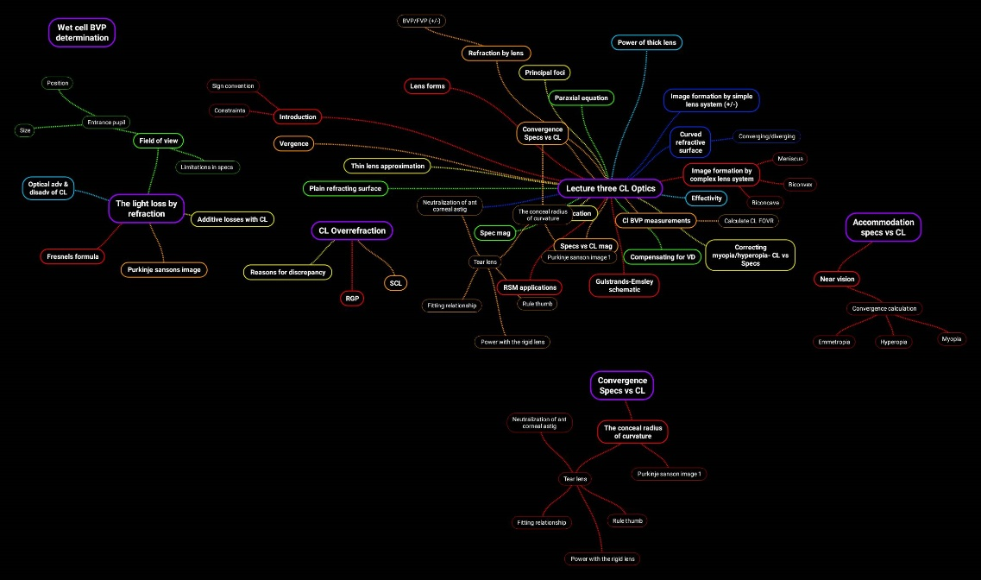
Scenario 3
Mrs B a nurse with MCH is a known myopic patient. She has been using glasses for the past 10 years. She has read about contact lenses and is considering switching from glasses. She wants you to explain in plain language how spectacles and cl handle light and make vision possible. How does the optics of cl differ from spectacles? are there no difference in terms of accommodation, convergence, and magnification.

Lecture 4
Topic: Contact Lens Design
Aim: the aim of the course is to understand contact lens design parameters for SCL and how they influence contact lens use.
Objectives:
At the end of this lecture the student should be able to:
1. identify the key contact lens parameters relevant for a successful contact lens wear
2. determine the most important design factors for contact lenses
3. explain the other considerations for SCL design
4. describe the designing of SCL aspheric
Time: 2 hours
Materials Required: Lecture video, textbooks, iacle PDF, journal articles,
Method: class discussion with presentations by students
Assessment: pop quiz
Test your Knowledge
- Contact lens parameters has no standards
- The most important design factors for contact lenses is center thickness
- When designing contact lenses, material properties are not important
- In SCL design the constitution for plus and minus lenses are the same
- The other considerations for SCL design are not applicable to Malawi
- Aspheric SCL contact lenses can easily be designed and manufactured
Scenario 4
Uncle J a known investor in the USA from Salima has just arrived back in Malawi. Knowing that you are an optometry student, he expresses interest to design a unique SCL for Malawi. Considering SCL parameters and design factors, what design would you recommend to him for Malawi? Justify your design to him by giving due consideration to the peculiarities of the Malawian environment.

Lecture 5
Topic: Contact Lens fabrication
Aim: the aim of the course is to understand contact lens material properties and the manufacturing process
Objectives:
At the end of this lecture the student should be able to:
1. identify the properties of an ideal contact lens material for producing contact lenses
2. describe methods of measuring the material properties both on the eye and outside the eye
3. identify best materials for GP and SCL manufacture
4. describe the various classifications of the materials for GP and SCL
5. explain the advantages and disadvantages of each material
Time: 2 hours
Materials Required: Lecture video, textbooks, iacle PDF, journal articles,
Method: class discussion with presentations by students
Assessment: pop quiz
Test your Knowledge
- Any contact lens material can be used for CL
- Manufacturers can test the material properties both on the eye and outside the eye
- GP current materials include MA, fluorine etc. to increase permeability
- GP manufacturing technique differs from SCL because it involves only molding and lathing
- Low water has more advantage over high water in Malawi because of its predictable behavior
- There are many types of tints for SCL, the most common is handling tints and they can be made through vat dye and reactive dye process
Scenario 5
After battling to get the right design for about 6 months uncle J is back ready to produce the first prototype before mass production. He brought with him two polymer engineers. Your responsibility is to provide them with details that would help them finalize the prototype.

Lecture 6
Topic: corneal oxygenation in Contact Lens wear
Aim: the aim of the course is to describe corneal oxygen requirements and how they influence contact lens wear
Objectives:
At the end of this lecture the student should be able to:
- Describe the measurement of corneal oxygenation for under the contact lenses, open and closed
- Differentiate between measurement of permeability and transmissibility for hydrogels, GP and SCL materials
- Explain oxygen requirement for different contact lens wearing modalities
- Describe corneal swelling and oxygenation for SCL and GP contact lense wear
- Identify the effect of eye closure on contact lens wear
Time: 2 hours
Materials Required: Lecture video, textbooks, iacle PDF, journal articles,
Method: class discussion with presentations by students
Assessment: pop quiz
Test your Knowledge
- Corneal oxygenation values for eyes that are open, closed and under the contact lens is the same
- Measurement of permeability, transmissibility for hydrogels, GP and SIHY materials are the same
- Extended wear and daily Wear have different oxygen requirement
- Corneal swelling as a side effect of poor corneal oxygenation for GP and SCL are the same
- The closure of the eyes normally produces corneal swelling which returns to normal after opening the eyes.
Scenario 6
Uncle J now wants to design specific lenses that would best suit various locations in Malawi. A contact lenses that can be used at peaks of mulanje, Zomba and Chiweta and areas in central and southern region. What specific characteristics would you be interested in? what specific tests would you want o carry out with what considerations?

Lecture 7
Topic: Contamination and Deposits
Aim: introduce the learner to contact lens deposit and its management
Objectives: at the end of this lecture students should be to:
- Differentiate between contaminants and deposits
- Describe deposits its etiologies, signs and symptoms
- Differentiate between types of deposits
- Describe the management of cl deposits
Time: 2 hours
Materials Required: IACLE PPT, PDF Text books
Assessment: pop quiz
Test your Knowledge
Scenario 7
The first cl patient you saw this semester, a tourist from Australia. His chief complaint was red eyes started three days ago. He has been wearing soft contact lens for the past five years. SLE revealed conjcutival injection of +3 but no discharge. When his contact lens was assessed you observed lots of dry greasy spot. The patient did remember not following the required hygiene protocol after enjoying potato chips with friends.
- What would likely come to your mind when considering some of the points discussed in this lecture about deposits?
- What type of deposits would you expect? Suppose he works with SOBO or he drives a mountain bike would it be different?
- How would you assess and classify the deposits if any?
- What would be your treatment plan?

Lecture 8 Defending the Ocular Surface
Topic: Defending the ocular surface in contact lens wear
Aim: This topic aims at review of ocular defense mechanism against different microorganisms and contact lens wear effect on them
Objectives:
At the end of this lecture the student should be able to:
- Summarize the different microorganisms and their characteristics
- Summarize the specific and non-specific host defense mechanism for the eye
- Describe the contact lens wear effect on specific immune system
- Describe the effect of contact lenses on cytokines and arachidonic metabolites
- Describe the expected changes for specific inflammatory condition
Time: 1 hour
Materials Required: Lecture video, textbooks, iacle PDF, journal articles,
Method: lecture video presentation or face to face to lecture and class discussion
Assessment: group discussion, assignments and quiz
Scenario 8
Considering Sam the tourist from Australia we met in Lecture 7, what specific defense mechanism of the eye, would you point out to him, that has helped his case not get worse, in order to reinforce compliance?
Lecture 9
Topic: Care and Maintenance and LCP
Aim: this course aims to introduce the learner to care and maintenance of Contact Lenses
Objectives: at the end of this lecture students should be to:
- Explain the purpose of lens care and maintenance
- Identify the various care products, their constituents and their uses
- Explain the role of rubbing and rinsing
- Describe a proper lens storage and lens case care
Time: 2 hours
Materials Required: IACLE PPT, PDF Text books
Assessment: pop quiz
Test your Knowledge

Scenario 9
As part of exit counselling for Sam, what would you explain about use of LCP and contact lens care? Which would you recommend for Malawi?

Lecture 10
Topic: Care and Maintenance of Silicone Hydrogel
Aim: this course introduces the learner to LCP products specific for hydrogels and silicone hydrogels
Objectives: at the end of this lecture students should be to:
- Describe LCP specific for hydrogels
- Compare LCP for hydrogel and silicone hydrogel
- Care of used hydrogel and silicone hydrogel
Time: 2 hours
Materials Required:
Assessment: pop quiz
Test your Knowledge
Scenario 10
Six months later Sam returns to tell you he will soon be returning to Sydney Australia. He has plans to return next year for another visit. He is thinking of switching to silicone hydrogel. What advice would you give him? How would it compare to the care maintenance of his hydrogel which he is currently using? Which would be the right one for Malawi?

Lecture 11
Topic: SCL Complications
Aim: this course introduces the learner to complications associated with use of soft contact lenses
Objectives: at the end of this lecture students should be to:
- Identify complication specific to SCL wear
- Describe the etiology, sign and symptom of each complication
- Discuss the various management strategies for each complication

Time: 2 hours
Materials Required:
Assessment: pop quiz
Test your Knowledge
Scenario 11
A Mzuni staff just came back from china for training. While in china he started using contact lenses but three weeks after his return he discovered that his vision was no longer optima. He felt it was due to change in weather. He complained his vision seems worse in the morning but gets better in the afternoon and get worse again in the evening. External exam revealed circumcorneal redness. What complication would be your first tentative diagnosis. How would such diagnosis be differentiated and managed

Lecture 12 Dry Eye and Contact Lenses
Topic: Dry eye and contact lenses
Aim: This topic aims at Review dry eye pathophysiology and the use of cl in dry eyes
Objectives:
At the end of this lecture the student should be able to:
- Summarize the anatomy and physiology of the tear film
- Summarize the causes of dry eye and its management
- Describe dry eyes testing
- Discuss the use of contact lenses in dry eye
- Describe current treatment algorithm for dry eyes
Time: 1 hour
Materials Required: Lecture video, textbooks, iacle PDF, journal articles,
Method: lecture video presentation or face to face to lecture and class discussion
Assessment: group discussion, assignments and quiz
Scenario 12
Miss B our patient from our last lecture has succeeded in wearing multifocal contact lenses for six months but she observed that during her monthly periods she experiences at least one week of dry feeling in the eyes. What would you do for her? Stop the lenses? What tests would you carry out and for what purpose? What would be your final recommendation?

Lecture 13 Sports and Contact Lenses
Topic: Contact lens and sports
Aim: This topic aims at introducing the student prescribing contact lenses for sports
Objectives:
At the end of this lecture the student should be able to:
- Describe the benefits of using contact lenses in sports
- Describe considerations for fitting athletes
- Differentiate the various fitting and modality decisions for various contact lens option
- Identify specific cl and its consideration for different types of sporting
- Describe the general management consideration for sporting patient
Time: 1 hour
Materials Required: Lecture video, textbooks, iacle PDF, journal articles,

Method: lecture video presentation or face to face to lecture and class discussion
Assessment: group discussion, assignments and quiz

Scenario 13
Peter one of your known patients of five years have been invited for the national teams’ trials. Peter is a known myope of -5D whose unaided VA is 6/36. He is worried he might not be allowed to participate. He wants another option to enable him participate. Using your knowledge of contact lens and sports how would you help Peter? What questions would you ask him? What options is available to him? Suppose the sports he is hoping to participate in is swimming. Prescribe for a him a suitable option apart from spectacles.
recommendations?

